Latest from Lutsk
Pastor Victor Melnychuk of The Resurrection Church Lutsk sends a big thank you to
Freeland church and friends for the prayers and financial support they have received.
This support has been of great help with all the extra people they have coming to their
church for food and help.

Thanksgiving Day Service in October led by Pastor Victor.
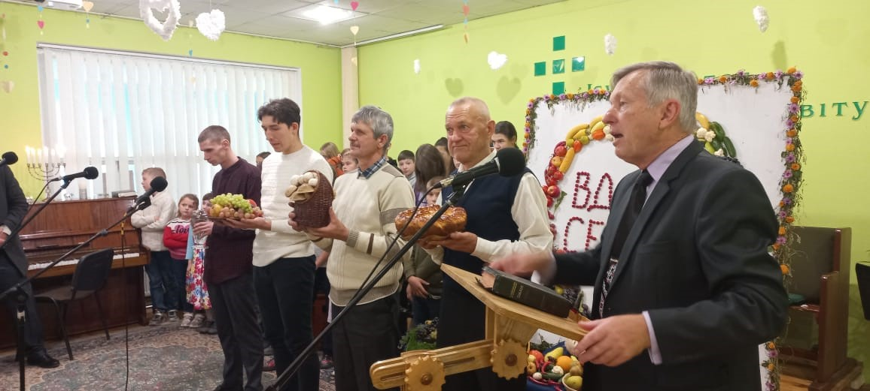

Photographs from Thanksgiving Day Service. A meal after the service with Pastor Victor.
